**ElectroHub Sales Analysis Report** - *by sakshi sahu*

1. **Executive Summary**
   1. ***Purpose of the analysis:*** ElectroHub is a company with multiple product categories. The primary goal of this analysis was to evaluate ElectroHub's sales data to determine which product category generates the most revenue.
   2. ***Objective of the analysis:*** This insight is crucial for strategic decision-making, such as optimizing inventory, focusing marketing efforts, and expanding high-performing product lines.

## Dataset Summary

* 1. ***Time period:*** Jan 2020 – Jan 2024
  2. ***Number of records:*** *3510 records*
  3. ***Key features:***
* ***Date*** – Sales transaction date
* ***Customer location*** – City, State
* ***Product details*** – Name, Category, Price
* ***Sales metrics*** – Units Sold, Sale Amount
* ***Discount metrics*** – Type, Offer, Discounted Amount

1. **Methodology of Analysis**
   1. ***Extract***

* Extracted the raw data which is in multiple tables from **Excel** to **Power BI**.
* ***Data understanding:*** Dataset have data in 4 different tables - Customer, Product, Promotion and Sales.
* ***Understanding schema:*** Customer, Product & Promotion tables belongs to Dimension or Parent Table, while Sales table belong to Fact or Child Table.
  1. ***Tranfsorm***
* ***Data cleaning:*** There is no wrong data, wrong datatype, duplicate record and missing value in the data set.
* Here we retrain the outlier in the price column as price of a product can be extreme as well as low.
* ***Data transformation:*** we will merge all the required column from multiple tables into sales table.
* ***Feature engineering:*** Creating new column like Unit Price, Discount Offer, Discount Amount and Sales Amount.
* Droping the unimportant columns from the sales table like CustomerID, ProductID and PromotionID.
  1. ***Load***
* Now the data is clean for analysis

1. **Visualizations & Insights**
   1. **The total sales, total discounts given, and total units sold.**

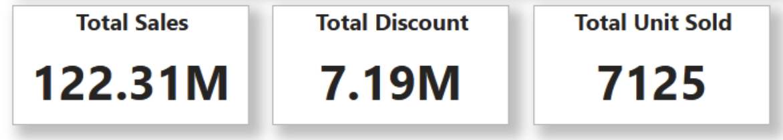

* 1. **Top/Bottom 5 products by sales.**

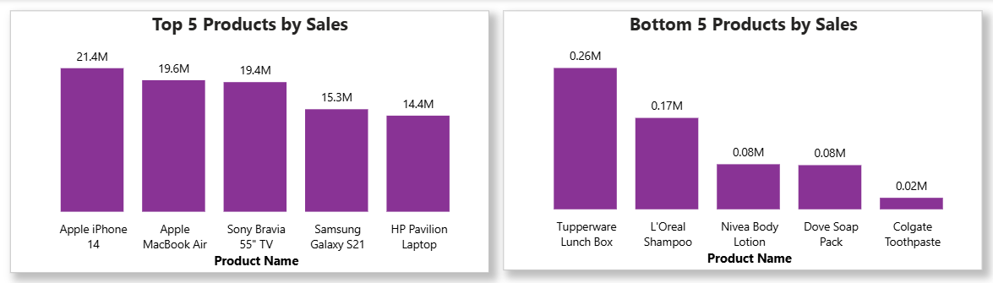

***Observation:*****Revenue is concentrated in premium electronics**, while **everyday products contribute more to unit sales but less to revenue**.

* 1. **Category wise contribution to the sales.**

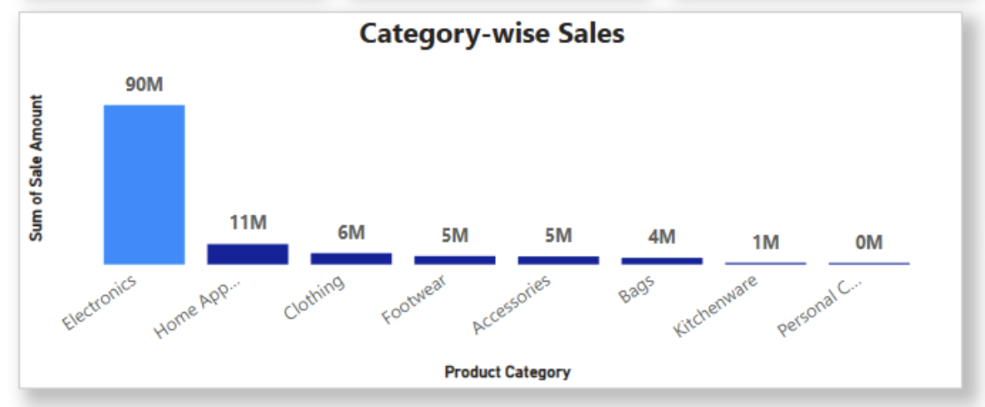

***Observation:*** Electronics is the clear leader with 90M in sales, far ahead of other categories. Most other product categories contribute only marginally, highlighting overdependence on Electronics.

* 1. **Sales trend over a period of time.**

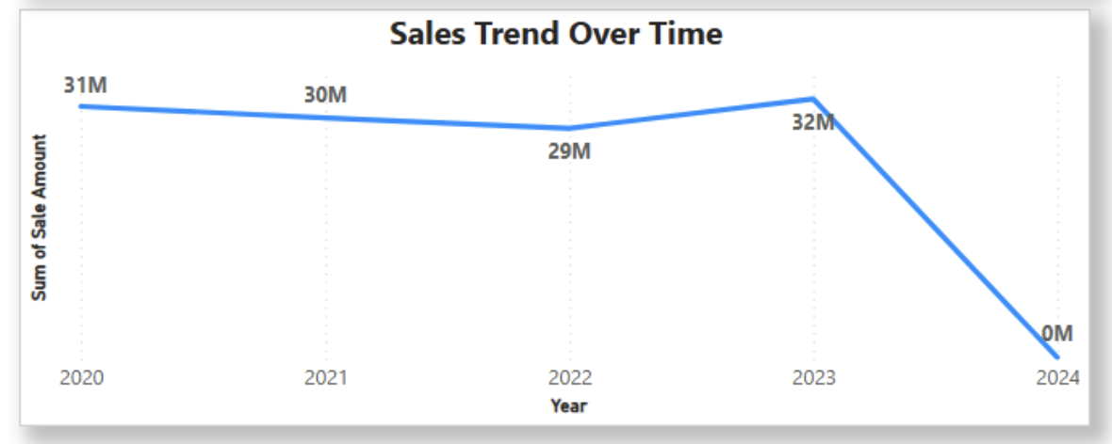

***Observation:*** Sales remained stable from 2020–2022, peaked in 2023, but dropped to zero in 2024, likely due to missing or incomplete data.

* 1. **Role of Discounts in Revenue Generation**

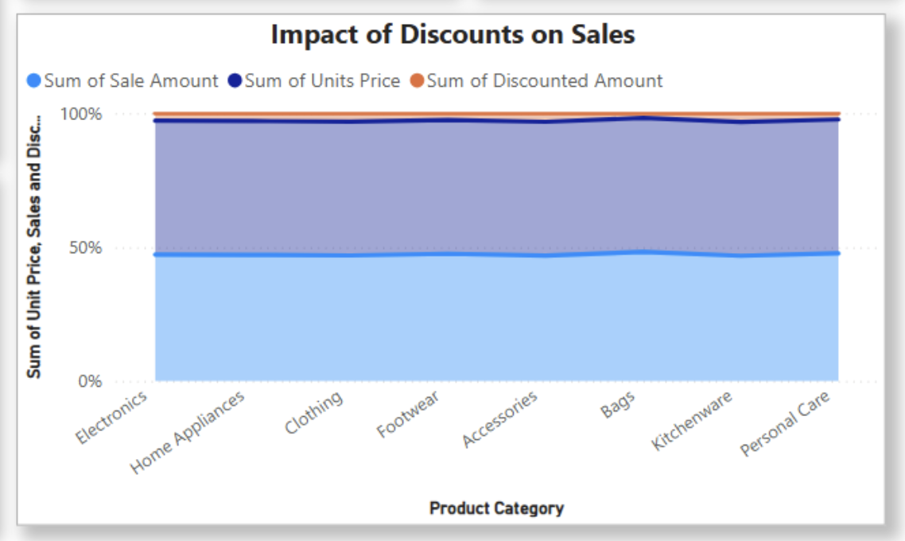

***Observation:*** Discounts had only a minimal impact across all product categories, as the **discounted amount remains very small compared to total sales**. Electronics and other high-value items generated strong sales largely without relying on discounts.

1. **Key Findings**

The analysis revealed that **Electronics** is the top-performing product category, contributing a substantial portion of the total sales. The second and third highest-grossing categories are **Home Appliances** and **Clothing**, respectively.

1. **Conclusion & Recommandation**

Based on these findings, it is recommended that ElectroHub continue to invest in the Electronics category and that the company should explore strategies to boost sales in other categories to ensure a balanced and diversified revenue stream.